Biography, Autobiography, and Memoir
Teacher Key
9th Lit/Comp Unit 2 Introduction – J. Chittaro

A biography is a piece of writing about a person's life.
- BIO- life; GRAPH - to write
- Biographies are written about a person's entire life, but are written by someone else. A biography about Labron James would NOT be written BY Labron - just about Labron.
- Sometimes, biographies are written about famous people without their permission or endorsement.

Biography Example: The Greatest: Muhammad Ali by Walter Dean Myers

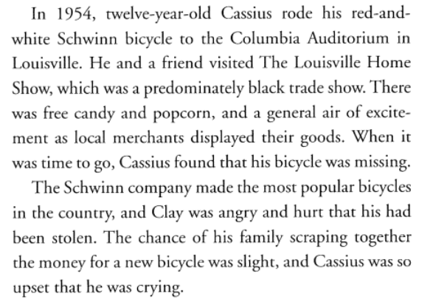
- Clues it's a Biography
- Written in 3rd person point-of-view
- "he", "she", subject's name

An autobiography is a history or story of a person's life written or told by that person.
- AUTO - self; BIO - life; GRAPH – write
- An autobiography is written BY the person the story is about.
- Sometimes, when a person wants to write their autobiography, but may not have the time or skill to actually write the book, another person called a GHOST WRITER actually writes or edits the author's story. This happens with many executives, celebrities, and political leaders.

Example of Autobiography: 100% Official Justin Bieber: Just Getting Started by Justin Bieber

- Clues it's an Autobiography
- Written in 1st person point-of-view
- "I", "me", "my", "we", "our"
- Reads as if the author (Justin) were talking directly to you

Review: Biography vs. Autobiography

Biography:
- Tells a story about a person's life
- Usually written from birth to death/present
- Written by someone other than subject of the book
- Third person point-of-view
- Clues: "he", "she", subject's name ("Cassius Clay")
Autobiography:
- Author tells a story about their own life
- Usually written from birth to present
- Sometimes written by a ghost writer
- First person point-of-view
- Clues: "I", "me", "we", "my"
- Reads as if the author were talking to you

A memoir [mem-wahr] is a record of events written by a person having intimate knowledge of them and based on personal observation.
- A memoir is like an autobiography except instead of covering a person's entire life; the memoir covers an unforgettable memory of a specific time in the author's life.
- Sometimes the memoir is made into a movie.
Example of a Memoir: 127 Hours: Between a Rock and a Hard Place by Aron Ralston
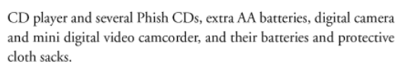
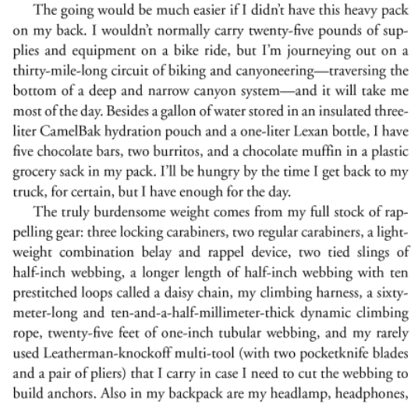

- Clues it’s a Memoir
- First person point-of-view
- Intimate memory of the morning Aron left - he tells details that other would not have known

Let’s Practice - Look at the following book excerpts. Using the information you have just learned, decide whether the selection is a biography, an autobiography, or a memoir. Highlight the clues.
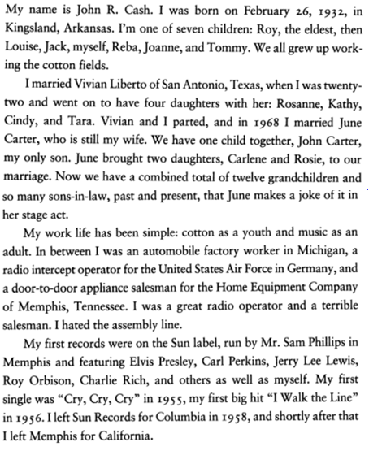
Example #1:

- This is an example of a _______________________________.

Example #2:
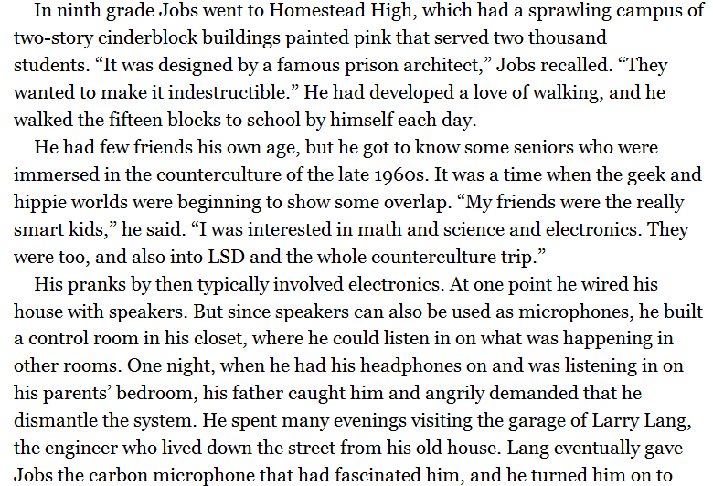

- This is an example of a _______________________________.
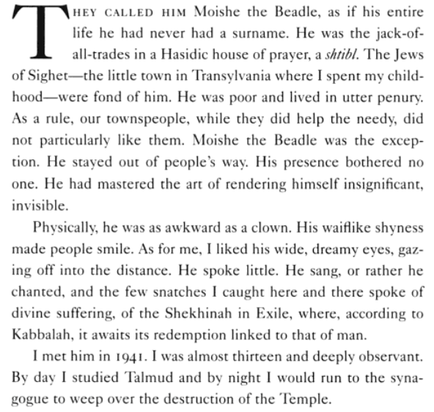
Example #3:

- This is an example of a _______________________________.

