Biography, Autobiography, and Memoir
Name ______________
Date _______________
Class Period _________
9th Lit/Comp Unit 2 Introduction – J. Chittaro

A biography is a ______________________________________________________________.
- BIO- _________; GRAPH - ________________
- Biographies are written about a person's _____________________, but are written by ______________________. A biography about Labron James would NOT be written BY Labron - just about Labron.
- Sometimes, biographies are written about famous people _______________ their permission or endorsement.

Biography Example: The Greatest: Muhammad Ali by Walter Dean Myers

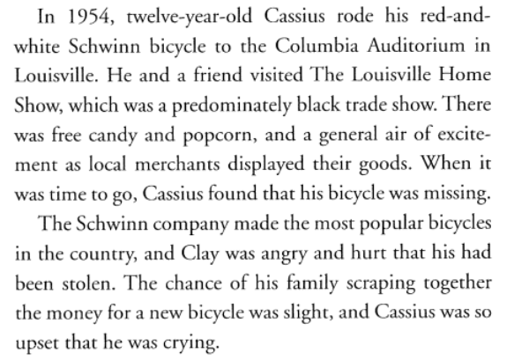
- Clues it's a Biography
- Written in ____________________ point-of-view
- "he", "she", ________________________

An autobiography is a history or story of a person's life ______________________________.
- AUTO - ____________; BIO - ___________; GRAPH – ________________
- An autobiography is written BY ______________________________________________.
- Sometimes, when a person wants to write their autobiography, but may not have the _______________ or ___________ to actually write the book, another person called a __________________________ actually ______________________________________. This happens with many executives, celebrities, and political leaders.
Example of Autobiography: 100% Official Justin Bieber: Just Getting Started by Justin Bieber

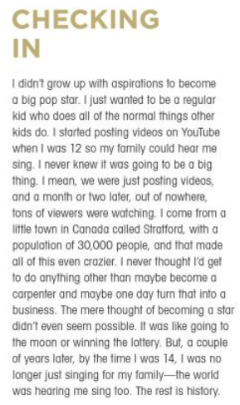
- Clues it's an Autobiography
- Written in _____________________ point-of-view
- "I", "me", "my", "we", "our"
- Reads as if the __________________________ (Justin) were __________________________

Review: Biography vs. Autobiography

Biography:
- Tells a story about a person's life
- Usually written from birth to death/present
- Written by someone other than subject of the book
- Third person point-of-view
- Clues: "he", "she", subject's name ("Cassius Clay")
Autobiography:
- Author tells a story about their own life
- Usually written from birth to present
- Sometimes written by a ghost writer
- First person point-of-view
- Clues: "I", "me", "we", "my"
- Reads as if the author were talking to you

A memoir [mem-wahr] is _______________________________ written by a person having _________________________ of them and based on _____________________________________.
- A memoir is like an autobiography except instead of covering a person's entire life; the memoir covers an _______________________________________ of a specific time in the author's life.
- Sometimes the memoir is made into a movie.
Example of a Memoir: 127 Hours: Between a Rock and a Hard Place by Aron Ralston
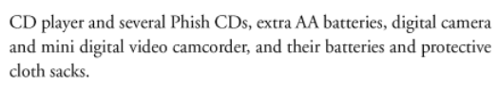
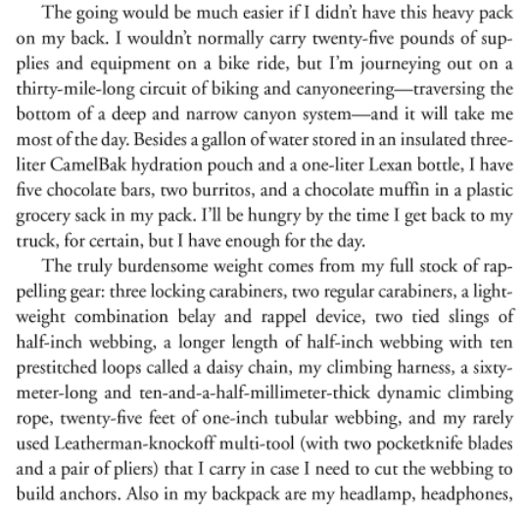

- Clues it’s a Memoir
- _________________________ point-of-view
- __________________________ of the morning Aron left - he tells details that other would not have known

Let’s Practice - Look at the following book excerpts. Using the information you have just learned, decide whether the selection is a biography, an autobiography, or a memoir. Highlight the clues.
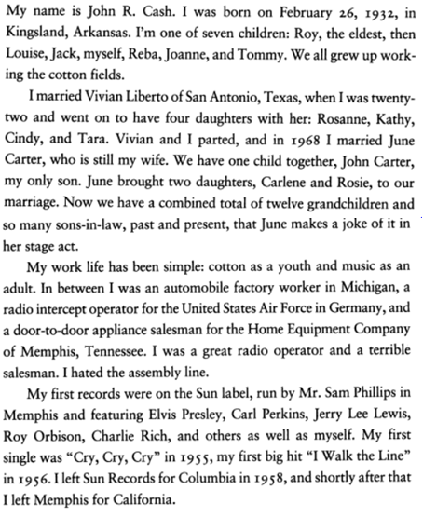
Example #1:

- This is an example of a _______________________________.

Example #2:
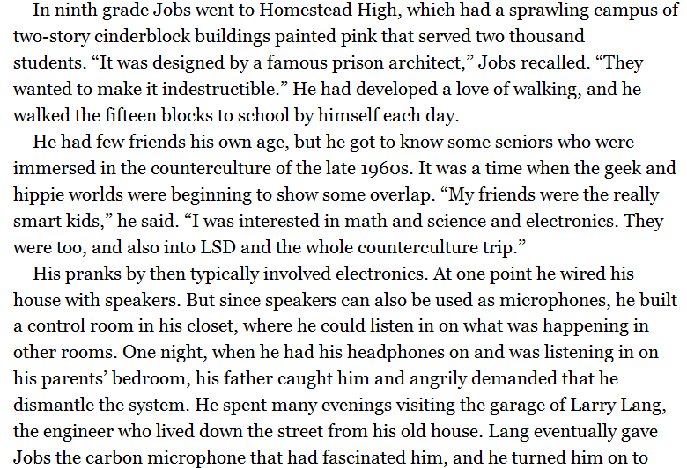

- This is an example of a _______________________________.
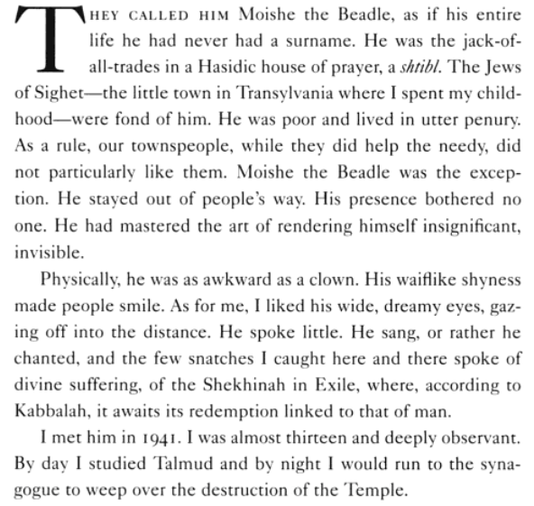
Example #3:

- This is an example of a _______________________________.

